**PORTABLE POWER FOR RASPBERRY**

1. **Why we choose “Lm2576adj - 3a Uni Reg Board” and “Lipo Battery” for create a portable power for raspberry?**

Raspberry use input is 5v and 1A so, we donot use battery AA or AAA for Raspberry. We choose lipo battery use for Raspberry because lipo battery supplies 11.1v and 1A.

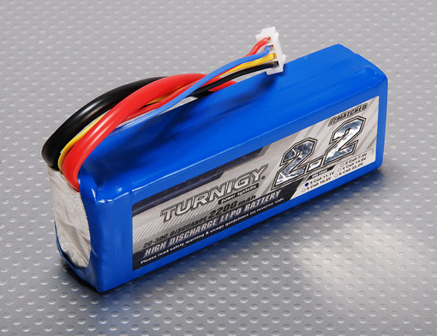

But Raspberry use input is 5v and 1A so, we need a circuit transformer convert from 11.1v to 5v.

That reason why, we choose **LM2576ADJ - 3A UNI REG Board.**

1. **LM2576ADJ - 3A UNI REG Board**

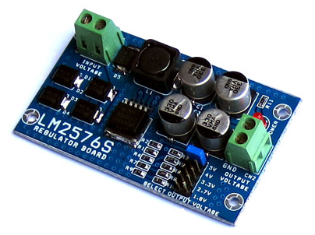

**Overview:**

* UNI-REG board allows changing voltages from 7-23V AC (or 9-32V DC) to 5V, 4V, 3.3V, 2.7V or 1.8V.
* Circuit Board using LM2576 - Step-Down Voltage Regulator.
* On-board screw-terminals are available for easy connection.

**Description:**

LM2576ADJ - UNI REG Board uses voltage regulator IC provides functional step-down (buck) switching regulator, capable of responding and changing load voltage lines are excellent. This is the ideal motherboard for projects requiring high voltage switching from lower to AC (DC).

Circuit Board accepts 7-23V AC input voltage (9-32V DC or), and stable output 5V, 4V, 3.3V, 2.7V or 1.8V DC, suitable for most electronics projects. The output voltage is selected via a jumper on the board. Compact and affordable, this board is perfect for use when switching power supplies are needed for your embedded project.

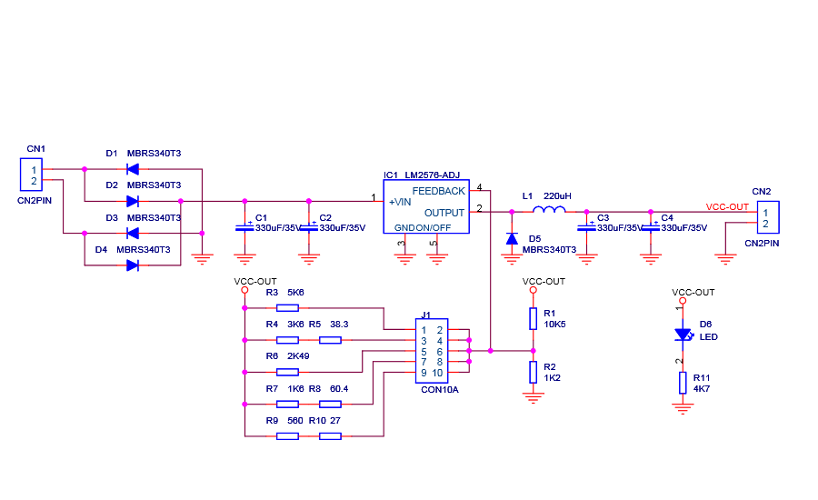

IC LM2576HV-ADJ

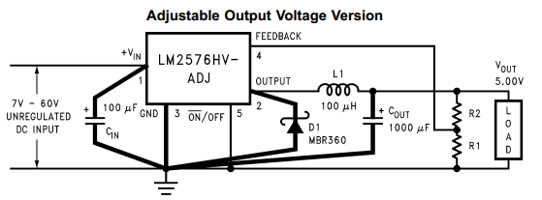

VOUT = VREF (1+ R2/R1)

R2 = R1(VOUT/VREF  - 1)

Where VREF = 1.23v, R1 between 1k and 5k

**Source:**

Alldatasheet.com